Mquiry solutions page (modeled based on RAPTER page)
Add to: Solutions > Digital Innovation > Solutions Built by Mathematica section
Logo options available on Canto
SOLUTIONS
Mquiry

A highly secure, cloud-based solution for data collaboration
Mathematica’s Mquiry platform enables researchers, data scientists, and engineers to gather, discover, manage, and analyze data securely. The platform simplifies insight dissemination and includes a centralized repository to ingest, store, and catalog structured and unstructured data and supporting materials, as well as an analytics workspace for data processing and in-depth analyses. Mquiry also provides connectivity to leading data visualization tools. With an intuitive user interface, security and governance controls, and leading data technology, Mquiry reduces burden on data collaborators and uncovers insights faster.

Get more information about Mquiry or request a demo.


How Mquiry puts relevant, reliable, data at your fingertips to drive insights and improvements
- Explore and search by keywords to find data sets
Researchers can access a centralized data repository, using keyword search to explore materials such as data sets and supporting documents. With built-in controls for restricting access, teams can easily preview available data and apply to gain access from data owners.
- Scalable computing resources
Data analytics teams can use powerful toolkit and scalable on-demand compute resources in the cloud. Mquiry provides best-in-class data analytics tools to support the data life cycle through ingestion, storage, cataloging, analysis, and reporting, complete with security, logging, and governance features.
- Collaborate easily in one platform
Mquiry facilitates team collaboration among interdisciplinary teams, which might include researchers, data engineers, data scientists, and others. With easy access to raw data, expandable data storage, and audit logs, users can work with data in one place without repeated downloads or copying data across multiple systems or locations.

- Focus on insights
Data analytics teams that support program operations and evaluation benefit from fast project startup and outsourced data infrastructure, leaving them with more time to focus on generating insights.
- Secure data sharing with partners
Research teams partnering with outside entities can authorize access to data sets within the platform, eliminating cross-organizational IT challenges. Mquiry’s strict security controls and audit and logging features provide robust data governance.

Features
Flexible import and export
Mquiry makes it easy to ingest large volumes of structured, unstructured, and semistructured data from multiple sources into one place, while ensuring proper quality control and easy data organization.
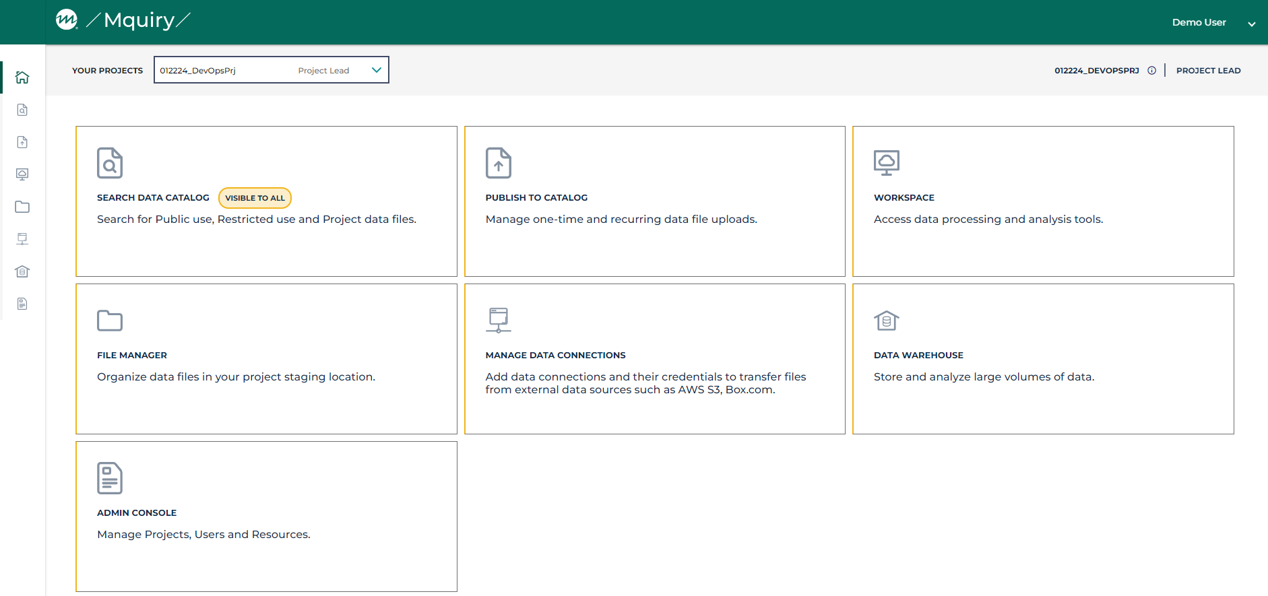
Data catalog and archive
Access publicly available data sets or build your own. Mquiry’s keyword search and filtering capabilities, along with its capacity to support a variety of data types, makes it easy to browse, find, preview, and share data, improving data accessibility and collaboration among research teams. The data catalog also includes controls and workflow features to ensure proper use of restricted data sets.
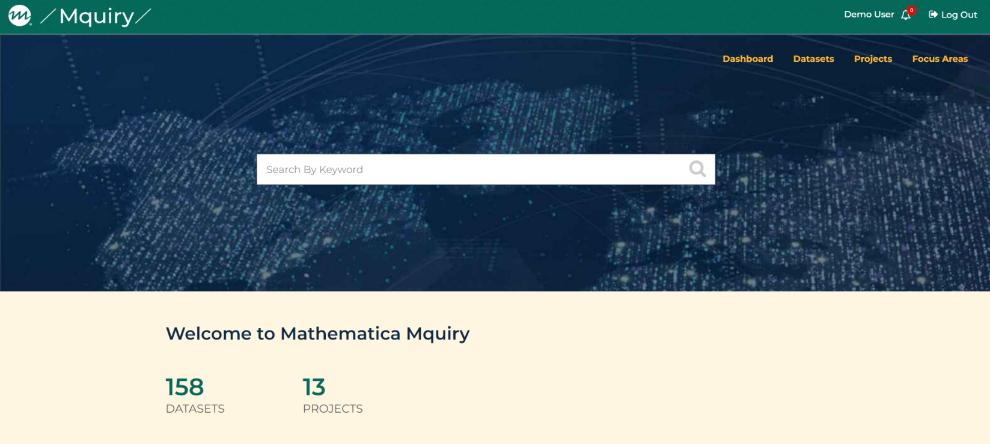

Processing workspace
Take advantage of scalable computing resources to easily process large data sets and manage your workloads through a built-in advanced analytics toolkit that includes RStudio, Stata, QGIS, Python, JupyterLab, and Visual Studio Code. These workspaces also come with office productivity tools and easily integrate with the GitHub code repository so data scientists, engineers, and analysts can share code and collaborate with team members.
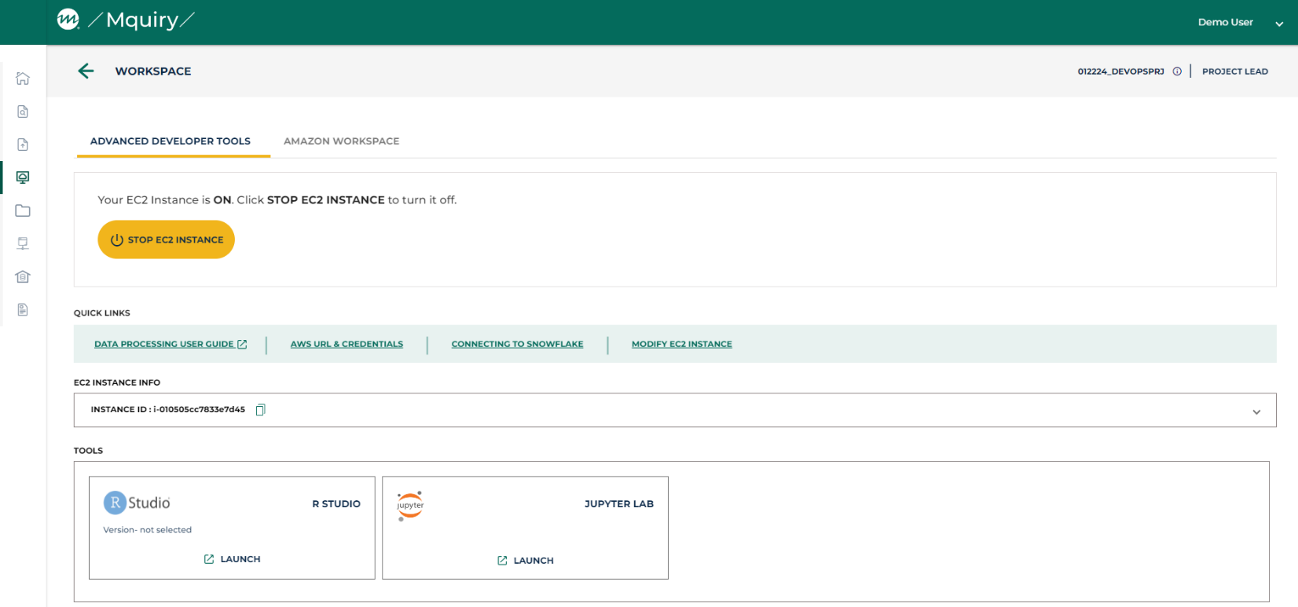
Data visualizations
Design and develop powerful visualizations for storytelling using tools such as Tableau, PowerBI, AWS QuickSight, or R Shiny to share research insights. You can connect visualization tools to unstructured and structured data in Mquiry and control access to these dashboards to secure your data and insights.
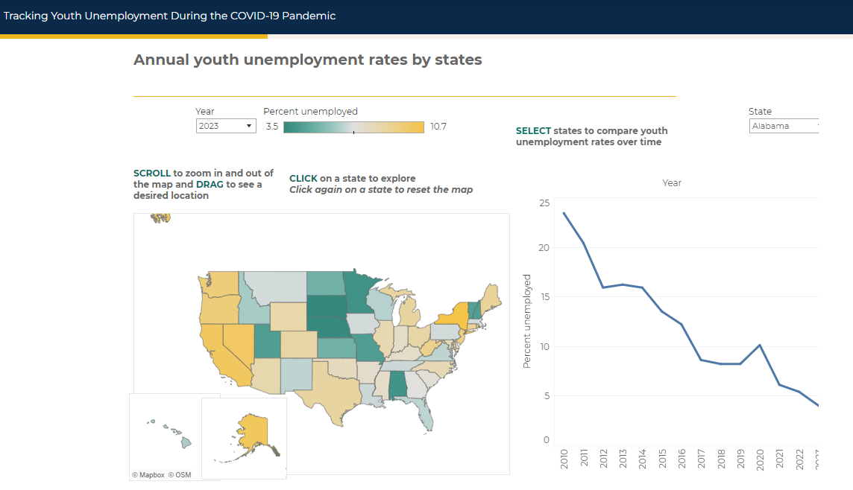
Security controls, auditing, and cost management

- Platform administrators can implement strict controls and manage user access to data and resources to meet privacy and compliance requirements. With Mquiry, you’ll have ready access to compliance reports and key metrics to ensure efficient use of resources and cost optimization.
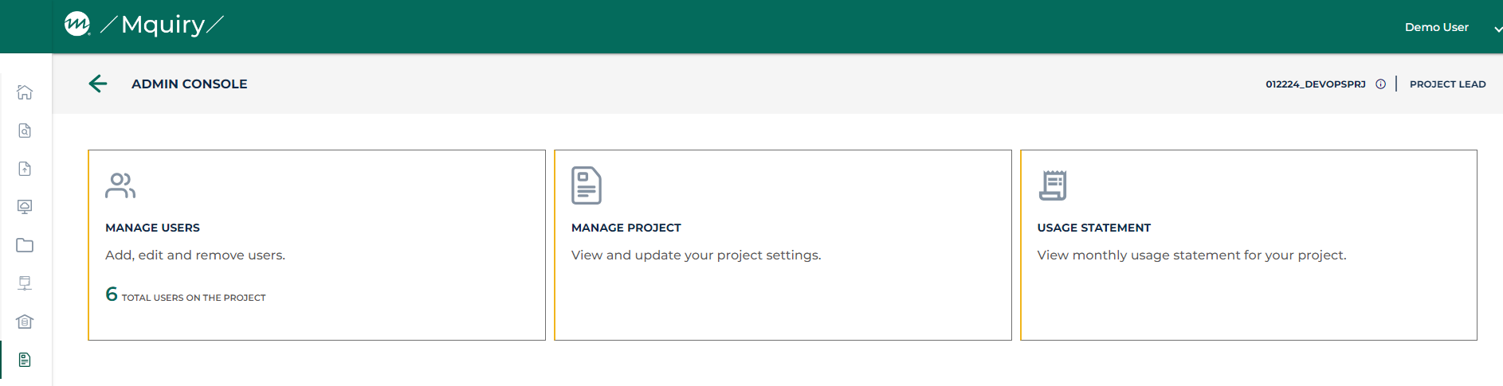

RELATED STAFF
Priya Narasimham [Images and links to bio pages]
Saba Karunanithi
Erika Krzton-Presson
Kate Miller
Mary Grider
Mark Flick
[CONTACT US form fields]

